Instruction for Install
We do on the project framework struts 2 and hibernate 4.
User default to login website:
- Username: admin, password: admin, Role: Admin
2) username: customer, password: customer, Role: Customer.

- Set up mysql service. Our use Wampp server
You need download wampp server and install:
Click Next button...
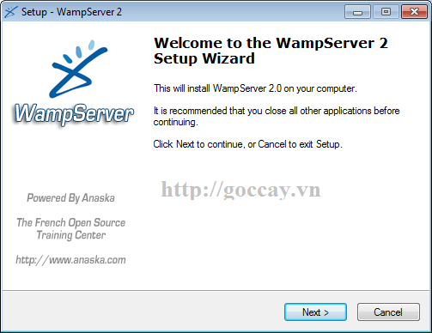

Chose accept then click Next
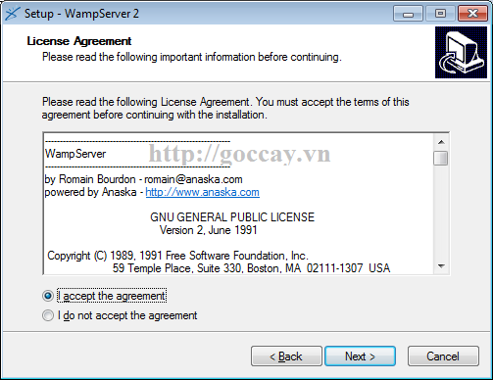

Browse to location you want to set up wampp
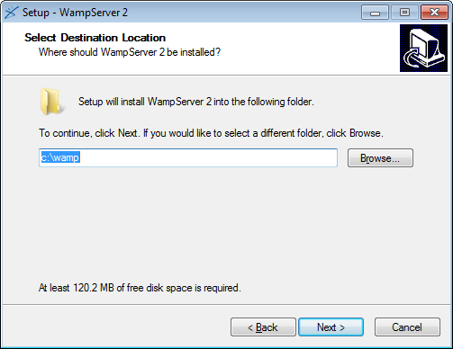
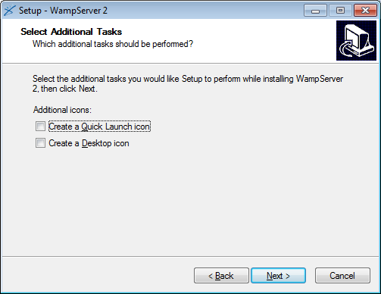

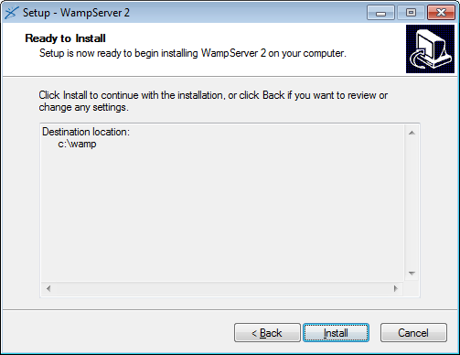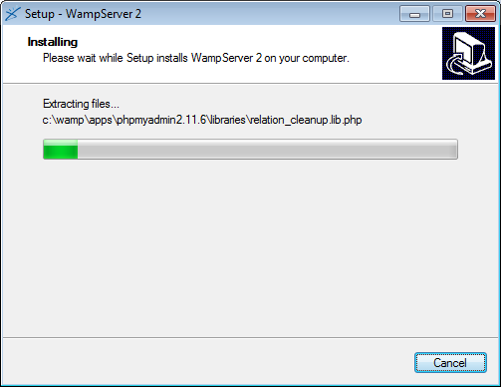

Chose Yes if you want to Firefox is browser default of wampp server
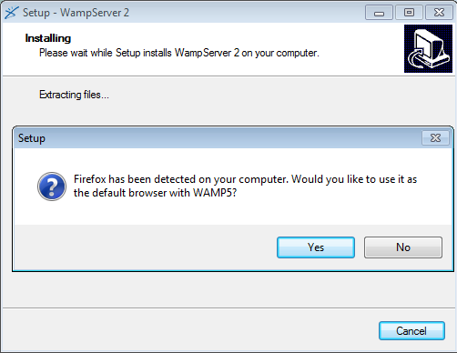
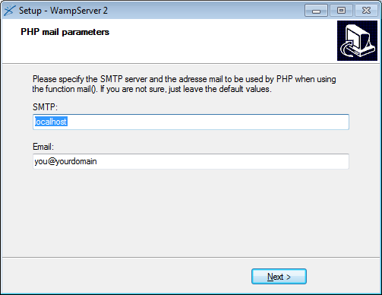

Click Finish to complete setup

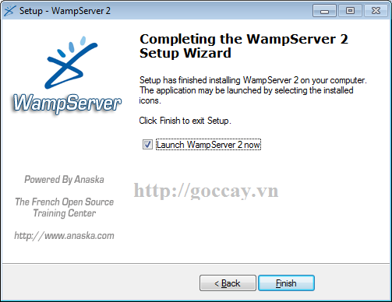

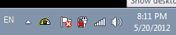

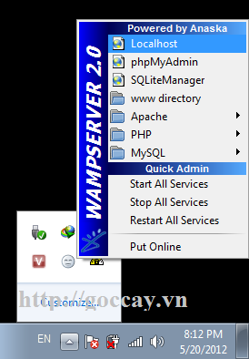

- Import database
Click phpMyadmin
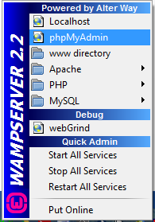

View browser is phpMyadmin login, login to mysql with username and password. My UserName is ‘root’, password is ‘project’. We will use it in config hibernate.
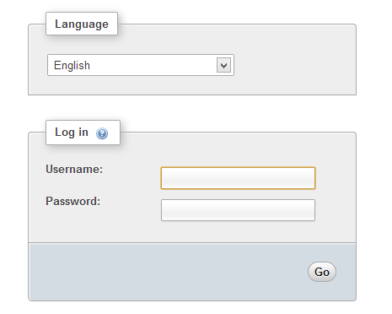
Login successfull, click database and create new database has name ‘easyticket’.
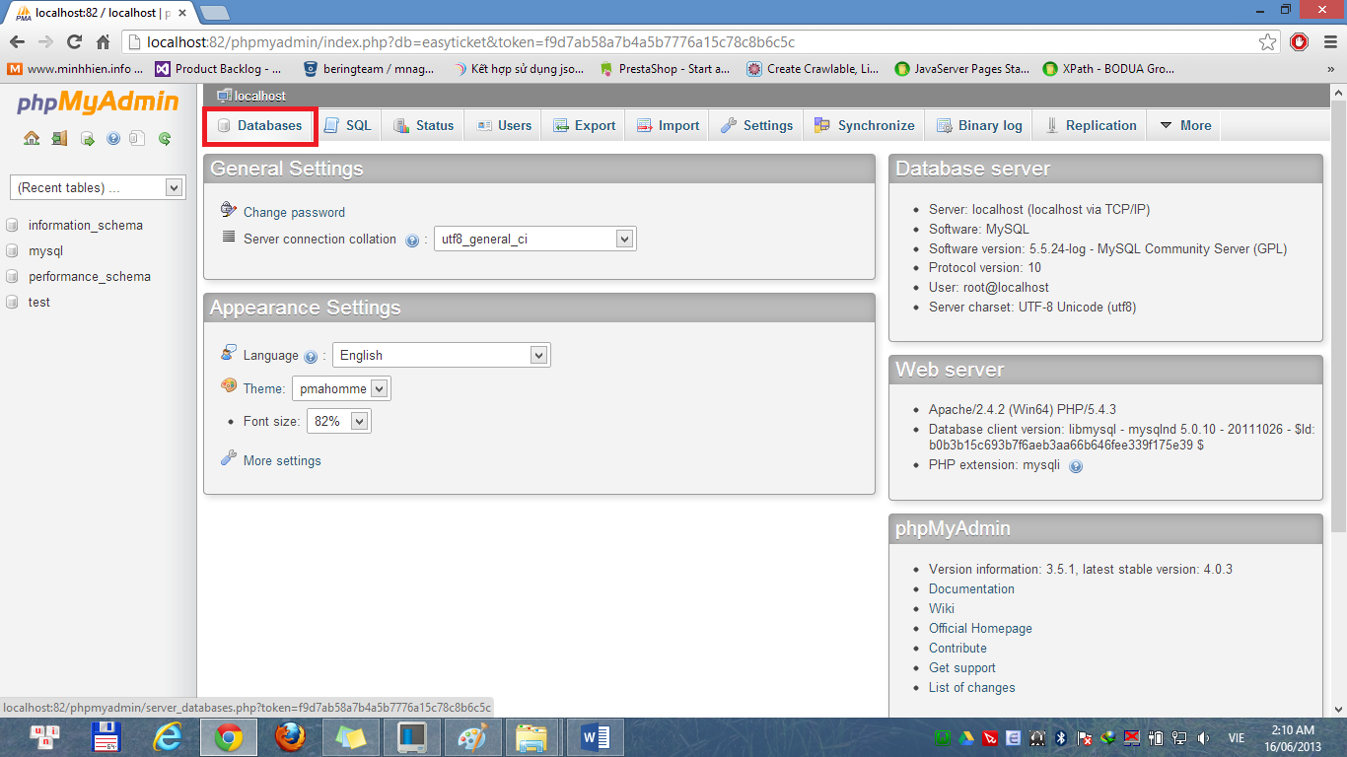
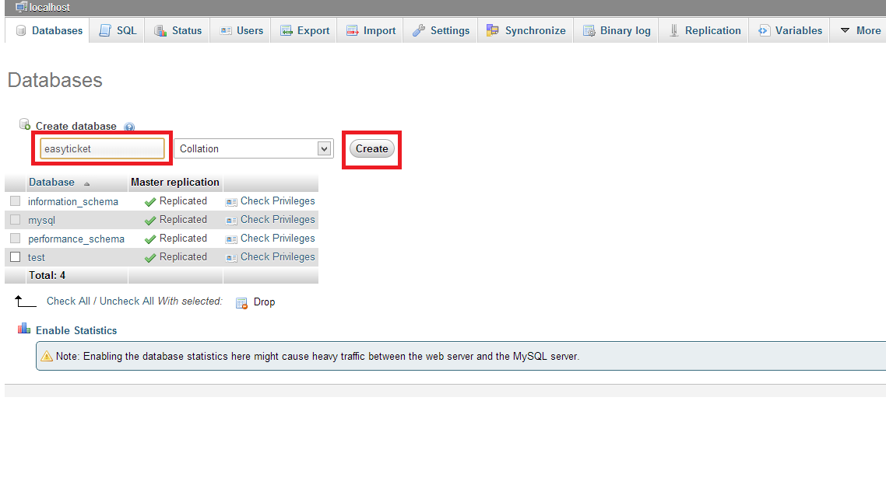

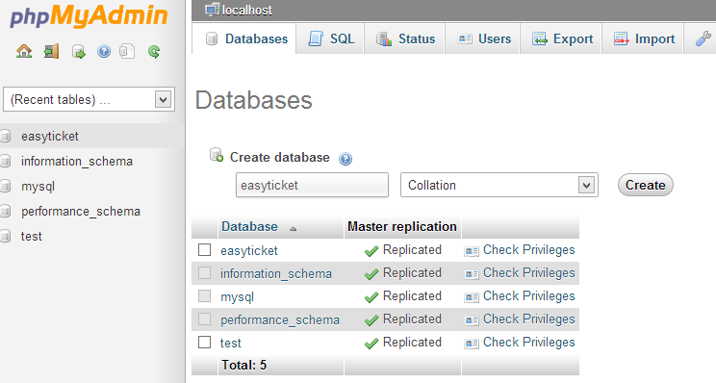

Click import to import database
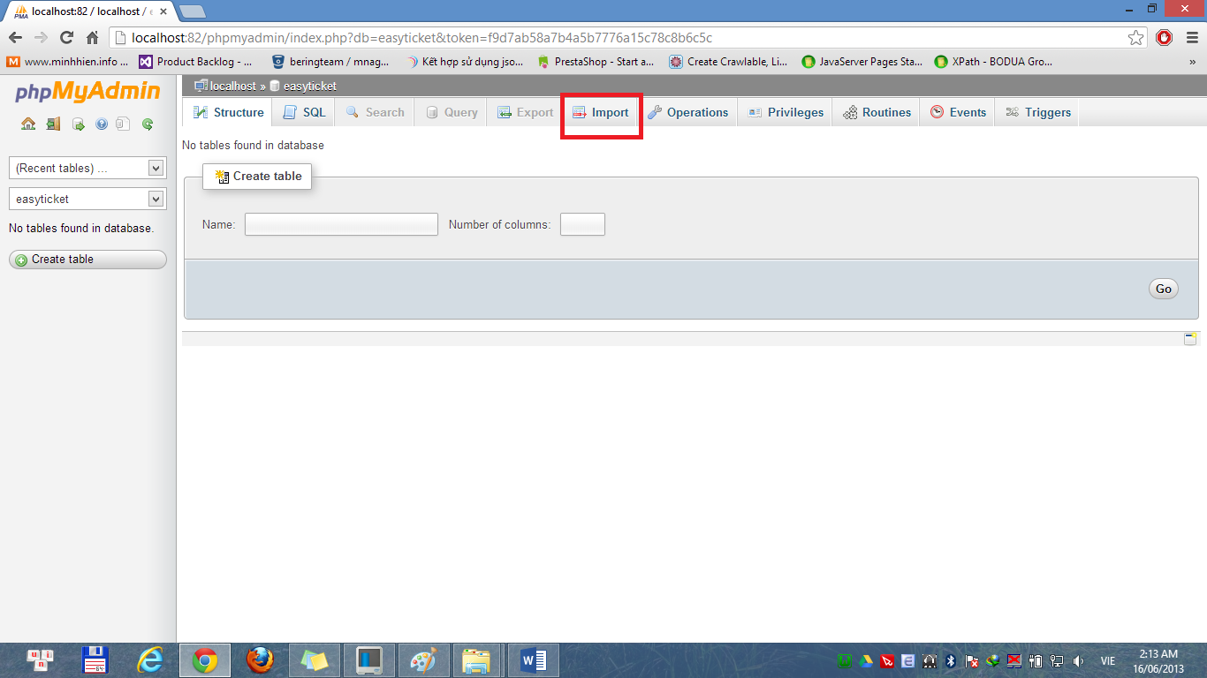

Browser to file easyticket.sql , click ok
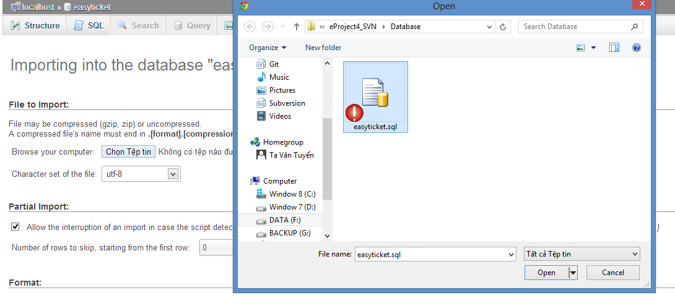

Import successfull
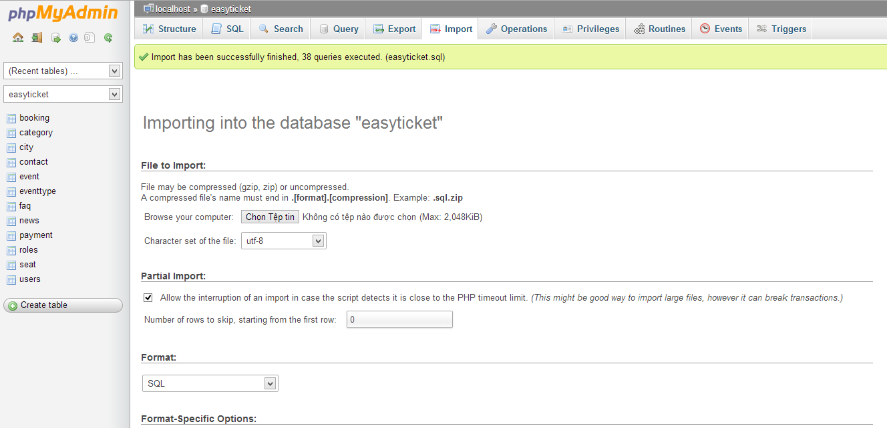

- Setup Eclipse and run project.
You need download eclipse (Eclipse IDE for Java EE Developers), tomcat 7, jre 7 to run this project
- Install jre
- Run file eclipse.exe in forder
- Choose browse create forder contain your projects
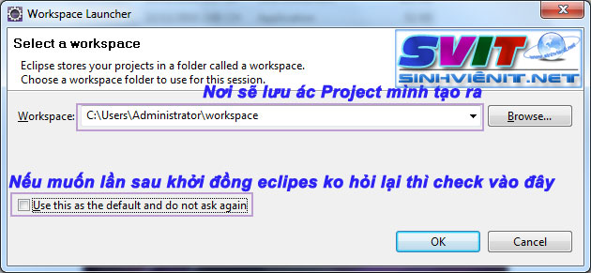

Welcome to eclipse! Setup successull, click ‘x’ to close this tag you will has new screen.

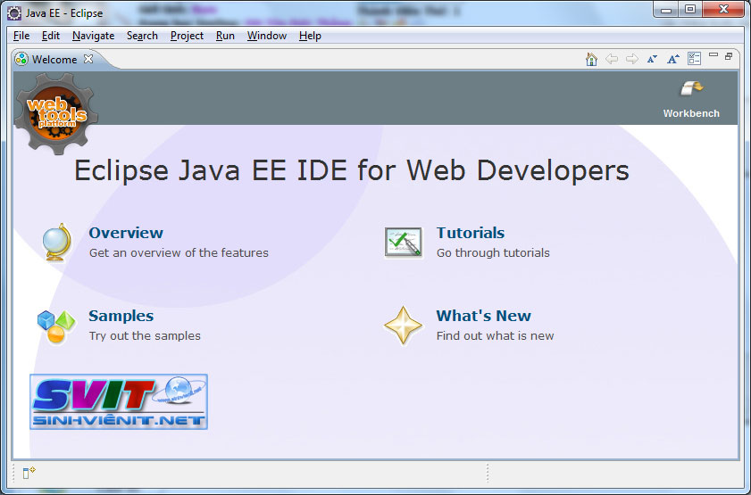
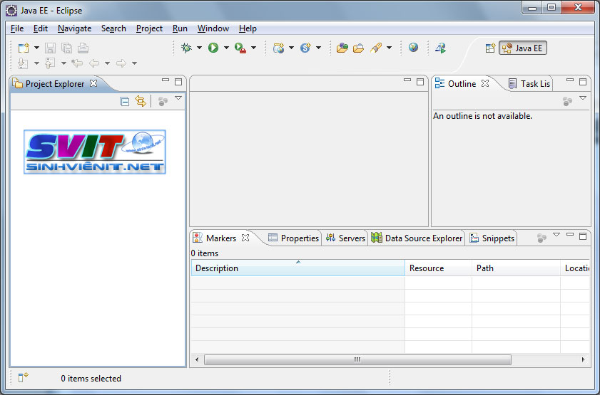
Chose File/Import

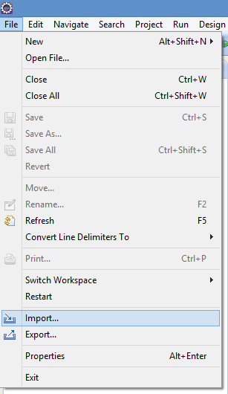

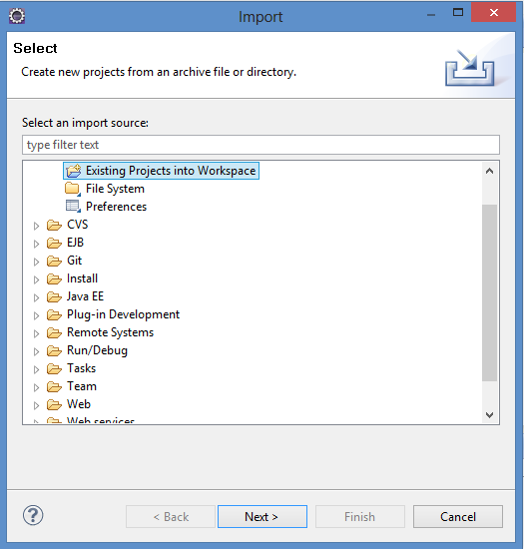

Browser to project, click Finish
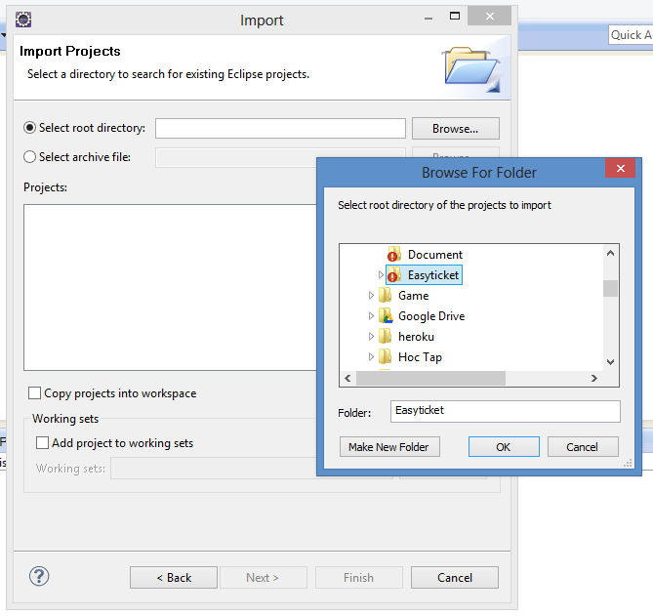

Import successful!
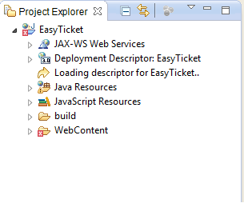
Add server tomcat: click ‘new server wizard’ in tab server
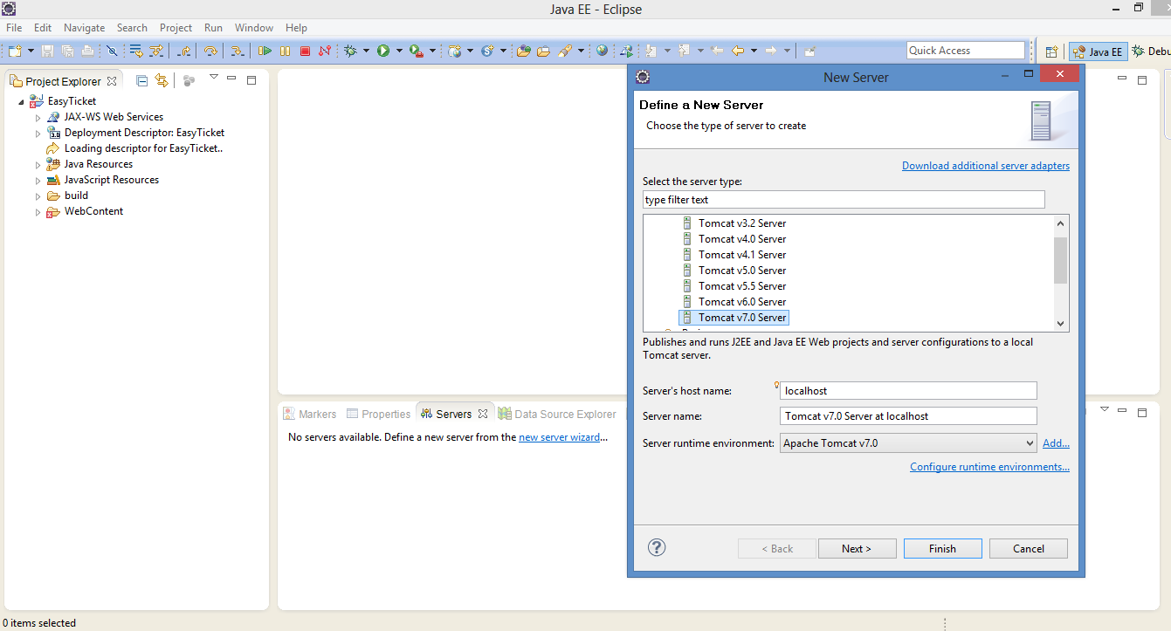
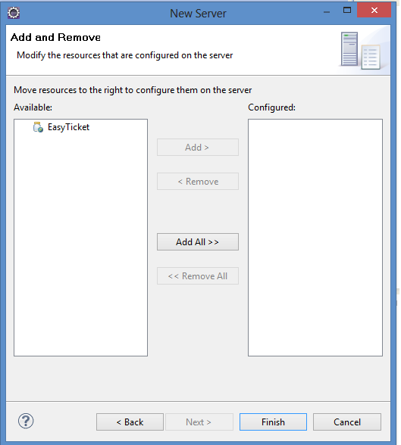

Click Add All, then click Finish
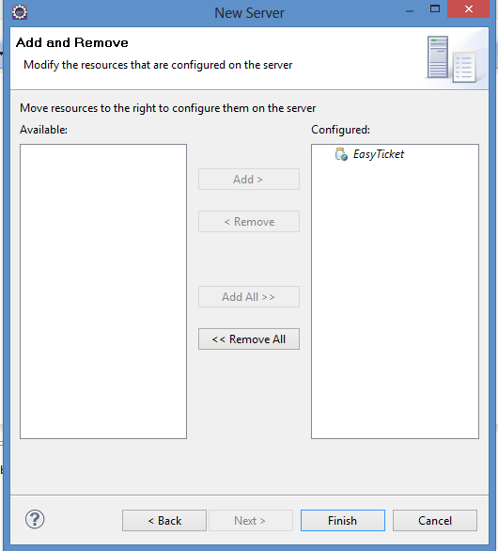

Open file ‘hibernate.cfg.xml’ in forder src to config
You need change value of property connection.username and connection.password to mapping entity class with table in database mysql
Connection.username : is UserName login to mysql
Connection.password : is Password login to mysql

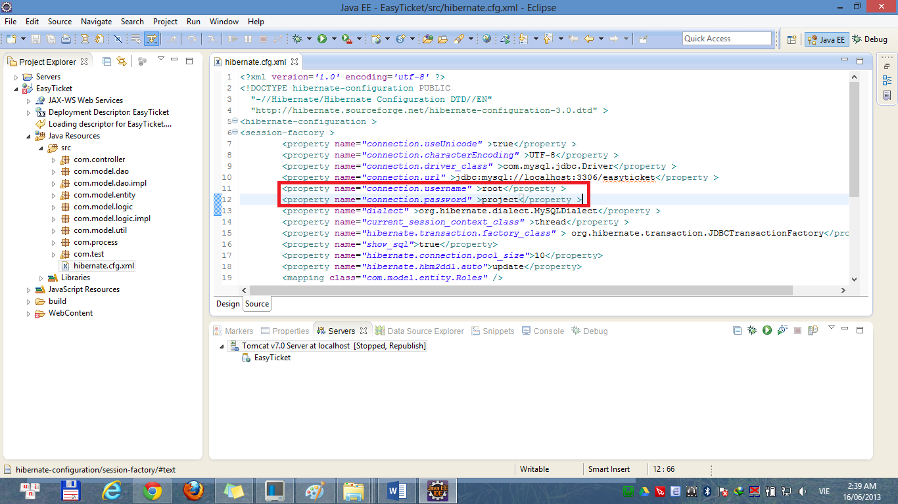

Start Server
